Practical 1 | Drugs affecting autonomic receptors of the eyes

INTRODUCTION

- Cholinergic (parasympathetic) control of the pupil and its receptor

BEFORE STIMULATION

AFTER STIMULATION
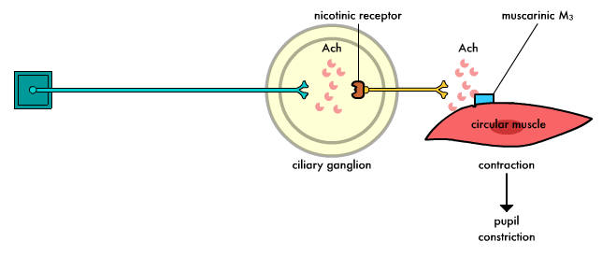

- Adrenergic (sympathetic) control of the pupil and its receptor

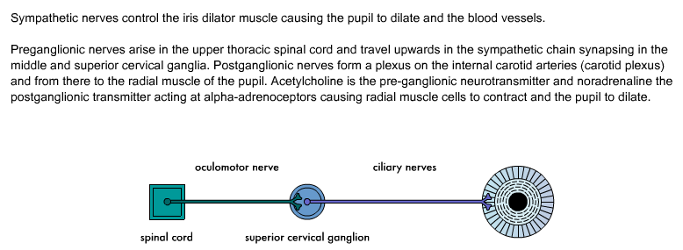
BEFORE STIMULATION

AFTER STIMULATION
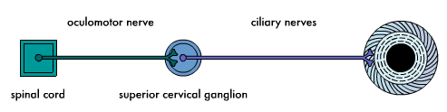
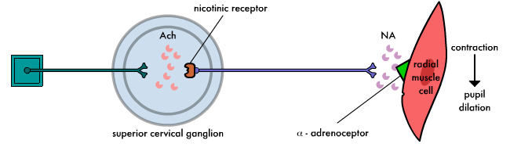

AIM(S)/OBJECTIVE(S)

In this simulation:

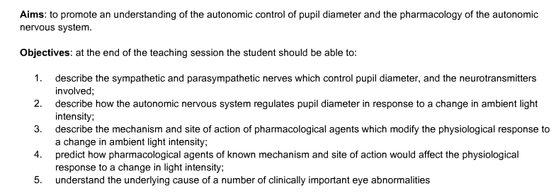

HARD- AND/ SOFTWARE

- A computer system/software

PROCEDURE

Before you apply any drugs to the eye:

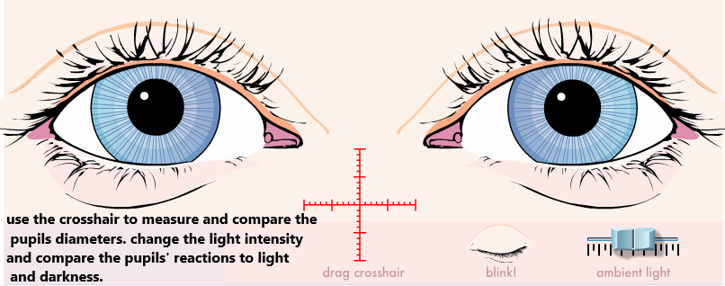

Click on “blink” button to observe the speed of reactivity of the pupils on both sides (symmetrical / asymmetrical).

Drugs affecting autonomic receptors used in this experiment:

The normal eye

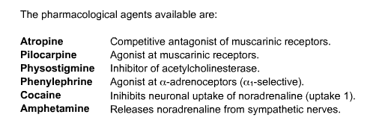

- Each agent will be applied externally to both eyes simultaneously at a single dose that is large enough to produce responses in eye that are responsive. Choose the drugs one by one from the drop-down list, then confirm with the “administer” button.
- In the first session of the experiment (TESTING AUTONOMIC DRUGS ON THE NORMAL EYES), students are expected to:
- Observe and record the reaction of pupils to changing (increasing or decreasing) light intensity.
- Observe the effect of each drug applied and record whether both pupils reacted symmetrically or asymmetrically using the “crosshair”.
- Use the “remove” button to immediately end the effect of the first drug before you apply the next drug.
- Present their results in a table form stating the effect on the pupil, the receptor involved (muscarinic or alpha-1 adrenergic), agonist or antagonist, whether the action was direct or indirect (in case the drug administered was an agonist).
- In case of asymmetrical diameters of the pupils “anisocoria”, determine whether this is physiological or pathological anisocoria.
- In the “Physiological type” the difference is mild and constant throughout the experiment.
In “Pathological anisocoria” the difference will increase with the application of topical drugs.

STUDENT’S TASK

- Explain the aim of the experiment.
- Point out the significance of the eye as an organ to recognize the effect of autonomic drugs.
- Tabulate the results of eye responses to stimuli (physical or drugs) as in the following:

STIMULUS | Pupil reaction | Active (agonist) / passive (antagonist) | Receptor affected | Agonist  Direct/ indirect | Effect on dilated blood vessels (red eye)
increasing light intensity | Miosis | Active | M3 | Direct | No effect
decreasing light intensity | Mydriasis | Active | α-1 | Direct | No effect
Pilocarpine | Miosis | Active | M3 | Direct | No effect
Physostigmine | Miosis | Active | M3 | Indirect | No effect
Atropine | Mydriasis | Passive | M3 | -------- | No effect
Cocaine | Mydriasis | Active | α-1 | Indirect | Vasoconstriction→ Pale
Phenylephrine | Mydriasis | Active | α-1 | Direct | Vasoconstriction
Amphetamine | Mydriasis | Active | α-1 | Indirect | Vasoconstriction

- Identify the patient whose eyes are affected by physiological anisocoria and justify the answer.

REPORT

The report shall consist of:

- Introduction (explain the scientific background and rationale for the experiment)
Write a paragraph stating about the significance of the eye as an organ to test autonomic drugs and description of light reflex and blinking reflex in the normal eye. What do you expect to learn from this experiment? Briefly describe the techniques you will use to understand the concept of autonomic drugs and their receptor on the normal eyes in this experiment.

- Material and methods (give enough details)
Outline the working of the simulation apparatus and the materials and reagents. Procedure describing step by step of the work that was undertaken.

- Results and Discussion (present in a clear or concise manner)
Complete the student’s task and include in the report appropriately. Interpret the findings of the experiment. Conclusion should be based on the results of the experiment.

- References
Please use relevant references to support your interpretation of the results.

