Practical 2 | Drugs affecting autonomic receptors of the eyes

INTRODUCTION

- Cholinergic (parasympathetic) control of the pupil and its receptor

BEFORE STIMULATION

AFTER STIMULATION
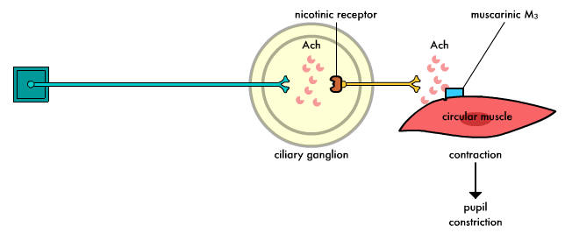

- Adrenergic (sympathetic) control of the pupil and its receptor

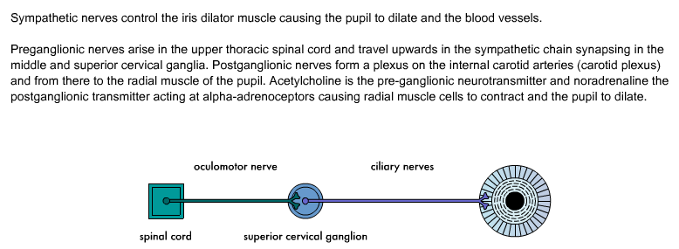
BEFORE STIMULATION

AFTER STIMULATION
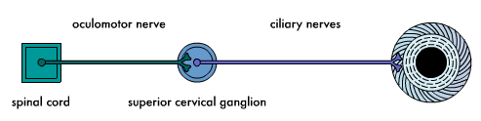
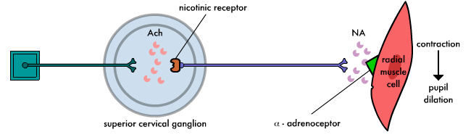

AIM(S)/OBJECTIVE(S)

In this simulation:

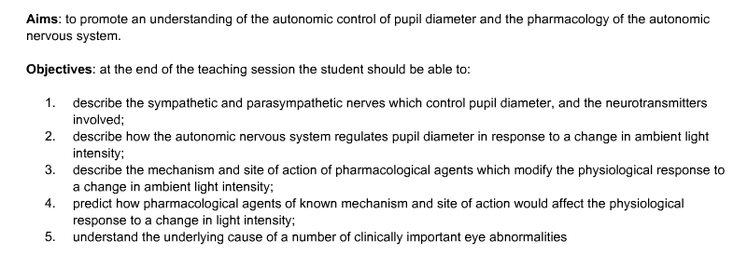

HARD- AND/ SOFTWARE

- A computer system/software

PROCEDURE

Before you apply any drugs to the eye:

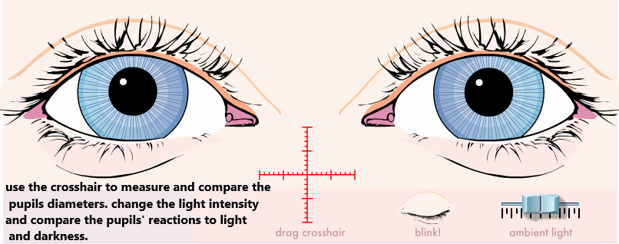

Click on “blink” button to observe the speed of reactivity of the pupils on both sides (symmetrical / asymmetrical).

Drugs affecting autonomic receptors used in this experiment:

The diseased eye

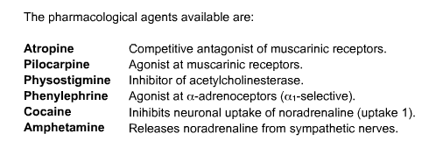
• Each agent will be applied externally to both eyes simultaneously at a single dose that is large enough to produce responses in eye that are responsive. Choose the drugs one by one from the drop-down list, then confirm with the “administer” button.
• Similar to the drug application in the first session of the experiment (TESTING AUTONOMIC DRUGS ON THE NORMAL EYES), students are expected to:
1- Observe and record the reaction of pupils to changing (increasing or decreasing) light intensity.
2- Observe the effect of each drug applied and record whether both pupils reacted symmetrically or asymmetrically using the “crosshair”.
3- Use the “remove” button to immediately end the effect of the first drug before you apply the next drug.
4- In case of asymmetrical diameters of the pupils “anisocoria”, determine whether this is physiological or pathological anisocoria.
• In the “Physiological type” the difference is mild and constant throughout the experiment.
In “Pathological anisocoria” the difference will increase with the application of topical drugs.

• In this second session of the experiment (TESTING AUTONOMIC DRUGS ON THE DISEASED EYES), students are expected to apply their knowledge earned during the first session using the autonomic drugs listed above to determine:
1- Which eye is the faulty one?
2- Which autonomic division (sympathetic / parasympathetic) is the cause for the disorder.
3- In case of sympathetic division disorder “Horner’s syndrome”, decide whether it is
“preganglionic or postganglionic”, based on the pupils’ reaction to the administered drugs.

STUDENT’S TASK

1- Explain the aim of experiment.
2- Using the same group of autonomic drugs used in the first session on the normal eye person
to:
a. Identify the patient(s) whose eye is affected by pathological anisocoria and justify the answer.
b. Identify the patient(s) whose eye is affected by preganglionic Horner’s syndrome and justify the answer.
c. Identify the patient(s) whose eye is affected by postganglionic Horner’s syndrome and justify the answer.
d. Identify the patient(s) whose eye is affected by partial parasympathectomy and justify the answer.
e. State one possible underlying cause / pathology that might have led to each of the three cases (b, c and d).
f. Suggest an additional drug that can be used to decide differentiate preganglionic from postganglionic parasympathetic lesion and describe the response of the affected eye to the suggested drug.

REPORT

The report shall consist of:

- Introduction (explain the scientific background and rationale for the experiment)
Write a paragraph stating about the significance of identification of the eye affected by autonomic dysfunction using light and blinking reflexes. What do you expect to learn from this experiment? Briefly describe the techniques you will use to understand the concept of using autonomic drugs and their receptor in detecting the eye affected by autonomic disorder in this experiment.

- Material and methods (give enough details)
Outline the working of the simulation apparatus and the materials and reagents. Procedure describing step by step of the work that was undertaken.

- Results and Discussion (present in a clear or concise manner)
Complete the student’s task and include in the report appropriately. Interpret the findings of the experiment. Conclusion should be based on the results of the experiment.

- References
Please use relevant references to support your interpretation of the results.

