PRACTICAL MANUAL

CARDIOVASCULAR, RENAL AND RESPIRATORY PHARMACOTHERAPEUTIC PHM 21003
Bachelor of Pharmacy with Honours [B.Pharm (Hons)]

Name:

Matric No.: _

LIST OF PRACTICALS
CARDIOVASCULAR, RENAL & RESPIRATORY PHARMACOTHERAPEUTIC PHM 21003
SEMESTER 2, YEAR 2

No. Title Page
- Practical 1: Effect of drugs on isolated frog heart 3
- Practical Report 1: Effect of drugs on isolated frog heart 4

Practical 1 | Effect of drugs on isolated frog heart
Objective | Exercise 1: To observe the contraction of the isolated frog heart.  Exercise 2: To observe the effect of certain drugs on isolated frog heart.  Exercise 3: To interpret the observation and explain the basis.  Exercise 4: To identify cardiac stimulants and cardiac depressant and understand the rationale of use in therapy.
Hard- and software | YouTube video
Procedure (s) | - Open the Microsoft word file ‘Practical Manual’.  - Open YouTube; Experiment No-02: Effect of drugs on isolate frog heart.  03_Effect of drugs on isolated frog heart at https://www.youtube.com/watch?v=onMUFQHkdGw  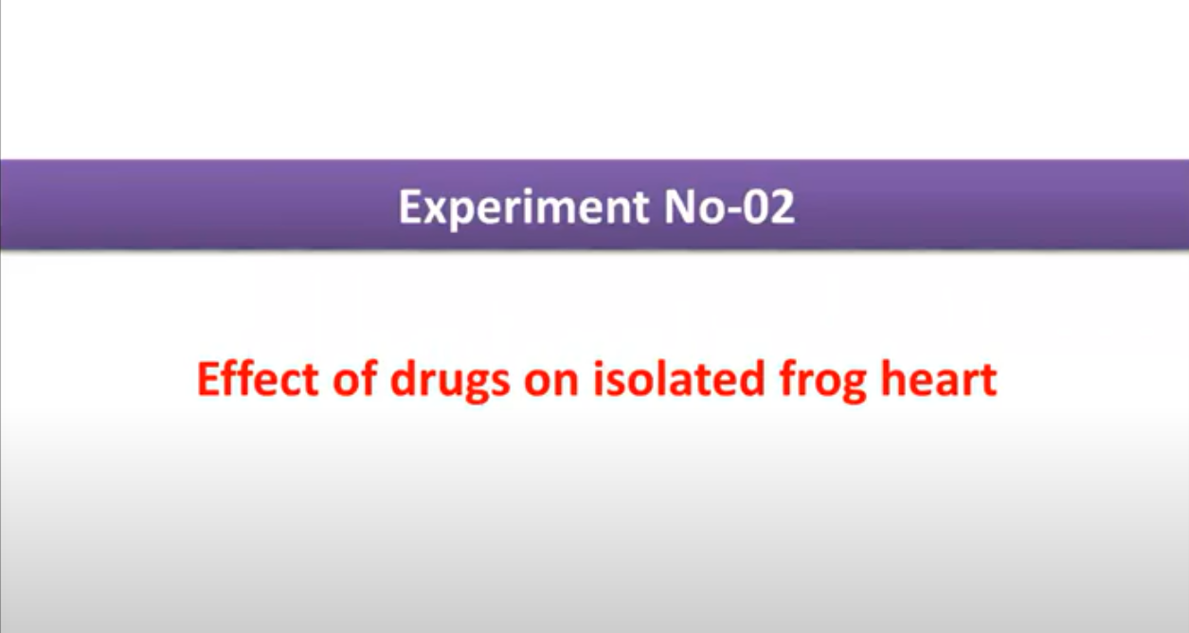
Student’s task | - Answer the following Study Questions in complete sentences.  - Define:  - Inotropic  - Chronotropic  - Dromotropic  - Explain the events occurring during:  - Administration of propranolol and adrenaline.  - Administration of propranolol and adrenaline with calcium chloride.  - Administration of atropine and acetylcholine.  - Administration of atropine and acetylcholine with potassium chloride.  - In the experiment, how to measure force of contraction, cardiac tone and cardiac rhythm?  - List cardiac stimulants and cardiac depressants and briefly explain the rationale for their use in therapy.  - You may discuss your finding in groups.
Report | - Complete the Introduction, Material and methods, Results and Discussion, Answers to the Study Questions and References of the Practical Report 1. The report shall consist of:  - Introduction (explain the scientific background and rationale for the experiment)  Write a paragraph stating about the theory of the contraction of the isolated frog heart and the effect  of certain drugs on isolated frog heart. What do you expect to learn from this experiment? Briefly  describe the techniques you will use to understand the concept of force of contraction, cardiac tone and  cardiac rhythm in this experiment.  - Material and methods (give enough details)  Outline the working of the requirement and preparation for this experiment. Procedure describing step  by step of the work that was undertaken.  - Results and Discussion (present in a clear or concise manner)  Represent all data appropriately and accurately. Interpret the findings of the experiment. Conclusion  should be based on the results of the experiment.  - Answer to the Study Questions  Complete the student’s task and include in the report appropriately.  - References  Please use relevant references to support your interpretation of the results.
References | https://www.youtube.com/watch?v=onMUFQHkdGw
Notes | Further reading:  https://www.youtube.com/results?search_query=Experiment+No-02%3A+Effect+of+drugs+on+isolate+frog+heart

Name: Matric No.: Date: Practical Report 1: Effect of drugs on isolated frog heart

Introduction

Material and methods

Results and Discussion

Answers to the Study Questions

References List your reference (s)

Notes To what extent were you satisfied with the practice session?

Very Dissatisfied
Very Satisfied

What is/are improvement (s) that you can suggest for this experiment?
1 2 3 4 5

