PRACTICAL MANUAL

CARDIOVASCULAR, RENAL AND RESPIRATORY PHARMACOTHERAPEUTIC PHM 21003
Bachelor of Pharmacy with Honours [B.Pharm (Hons)]

Name:

Matric No.: _

LIST OF PRACTICALS
CARDIOVASCULAR, RENAL & RESPIRATORY PHARMACOTHERAPEUTIC PHM 21003
SEMESTER 2, YEAR 2

No. Title Page
- Practical 2: Effect of drugs on blood pressure and heart rate of dog 3
- Practical Report 2: Effect of drugs on blood pressure and heart rate of dog 4

Practical 2 | Effect of drugs on blood pressure and heart rate of dog
Objective | Exercise 1: To observe effect of sympathomimetic drugs on blood pressure.  Exercise 2: To observe procedure involved in study of drugs on blood pressure and heart rate of dog.  Exercise 3: To interpret the observation and explain the basis.  Exercise 4: To observe the effect of epinephrine, norepinephrine, isoproterenol, angiotensin – II and tyramine on blood pressure and heart rate of dog.
Hard- and software | YouTube video
Procedure (s) | - Open the Microsoft word file ‘Practical Manual’.  - Open YouTube; Experiment No-03: Effect of Drugs on Blood Pressure and Heart Rate of Dog.  04_Effect of Drugs on Blood Pressure and Heart Rate of Dog at https://www.youtube.com/watch?v=SLHSbgkw4uc  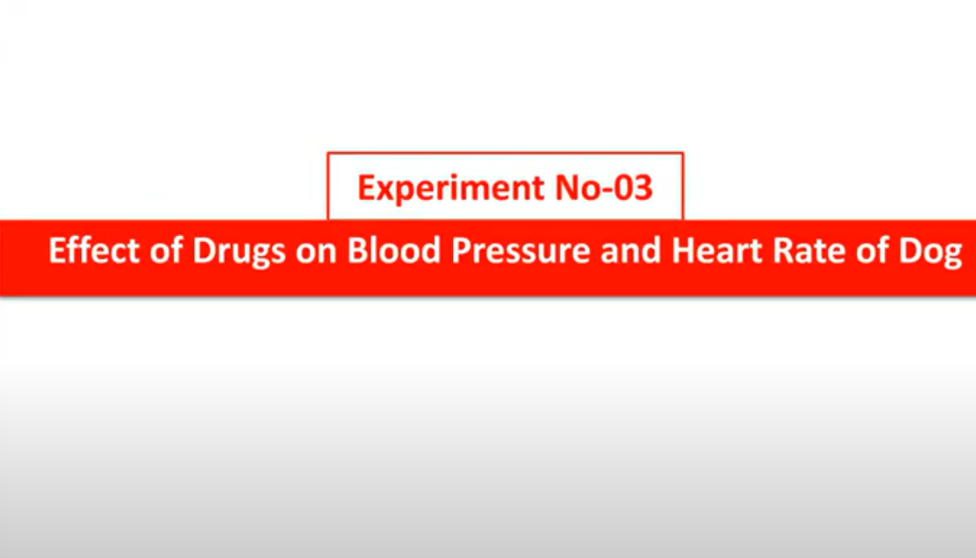
Student’s task | - Answer the following Study Questions in complete sentences.  - Briefly discuss the mechanism of action of epinephrine, norepinephrine, isoproterenol, and tyramine in controlling blood pressure and heart rate.  - You may discuss your finding in groups.
Report | - Complete the Introduction, Material and methods, Results and Discussion, Answers to the Study Questions and References of the Practical Report 2. The report shall consist of:  - Introduction (explain the scientific background and rationale for the experiment)  Write a paragraph stating about the theory of the effect of drugs on blood pressure and heart rate of dog. What do you expect to learn from this experiment? Briefly describe the techniques you will use to understand the effect of epinephrine, norepinephrine, isoproterenol, angiotensin – II and tyramine on blood pressure and heart rate of dog in this experiment.  - Material and methods (give enough details)  Outline the working of the requirement and preparation for this experiment. Procedure describing step by step of the work that was undertaken.  - Results and Discussion (present in a clear or concise manner)  Represent all data appropriately and accurately. Interpret the findings of the experiment. Conclusion should be based on the results of the experiment.  - Answer to the Study Questions  Complete the student’s task and include in the report appropriately.  - References  Please use relevant references to support your interpretation of the results.
References | https://www.youtube.com/watch?v=SLHSbgkw4uc
Notes | Further reading:  https://www.youtube.com/results?search_query=  Experiment%3A+Effect+of+drugs+on+blood+pressure+and+heart+rate+of+dog.

Name: Matric No.: Date: Practical Report 2: Effect of drugs on isolated frog heart

Introduction

Material and methods

Results and Discussion

Answers to the Study Questions

References List your reference (s)

Notes To what extent were you satisfied with the practice session?

Very Dissatisfied
Very Satisfied

What is/are improvement (s) that you can suggest for this experiment?
1 2 3 4 5

